**3 working solution to fix your computer overheating issues and 3 causes behind it**

Every electronic device starts to heat up when used for an extended period of time. So, the overheating issue isn't a rare case only present in your device. But in this article we will only talk about overheating issues in PCs.

If your PC’s fans are making very loud noises and your PC is hot to the touch, then overheating is the reason behind this. Overheating not only causes your PC to overheat, but it also damages other hardware components.

But nowadays, modern PCs simply **turn off** if the CPU or GPU heat reaches its maximum. However, such instances still damage your PC. Most users don't go for their PC maintenance, so it is recommended to visit a PC maintenance store every 6 months to clean your PC to prevent overheating and other issues. You can also clean by yourself if you have the necessary equipment at home and have some basic hardware knowledge.

**How can one be sure if their computer is overheating?**

It is common if your PC overheats when you are gaming, editing videos or even opening multiple programs at a time. But, if your PC starts to heat even if you are simply using google chrome or watching a youtube video in a browser then you can be sure that something is wrong with your PC and needs your immediate attention.

**The three causes**

The cause might vary according to PC to PC or processor to processor. So, five reasons that might cause overheating of your PC will be discussed in this section.

**Cause 1 – Fault in cooling system**

Components inside a PC need to do multiple tasks so they generate a lot of heat and the components need a certain temperature to work properly. A cooling system in a PC helps to reduce the temperature of a PC. So, the cooling system needs to be first checked before applying other solutions to solve the overheating issues. Cooling system consists of fans and heat sinks. If either fans or heat sinks are faulty or dust has built up in them then overheating issues arise as they are needed to dissipate hot temperature from inside of the computer to outside.

**Cause 2 – Old and dry thermal paste**

If you have purchased your PC a long time ago then the thermal paste in the CPU has gone old and dry due to which your PC will heat. A thermal paste generally helps to reduce the generated heat from your PC by transferring heat away to the heat sink. If you aren’t an expert then don’t try to put thermal paste in the CPU as it may damage other components inside the CPU.

**Cause 3 – The other issues**

Other issues that cause your PC to overheat are:

* If you haven’t updated your system to the latest version of windows.
* If an untrusted application is running in the background.
* Due to overclocking. So, close unnecessary applications.
* Due to improper set up of your hardware components.
* Using your PC for a long duration of time.
* If you have an old PC then it mighn’t handle the latest or newer programs which may cause overheating.

There might be other causes also.

**Monitor your processor temperature**

There is not a predefined criteria on how much your processor temperature should be to be on a safer side. Intel processors have certain criteria and other processors such as AMD have another criteria. But, a modern processor can handle about 100 degrees Celsius until the system is forced to shutdown on its own to protect the system. So, to monitor the temperature of your PC whether they are Dell, HP or have AMD, Intel as their processor you can monitor them using [**CoreTemp**](https://www.alcpu.com/CoreTemp/). Using this program you can see the temperature readings of our PC. If the temperature reading is too much (like exceeds 85 degree celsius) then you can close certain applications to be on a safer side. So, this program is very helpful to protect your system from any kind of damage.

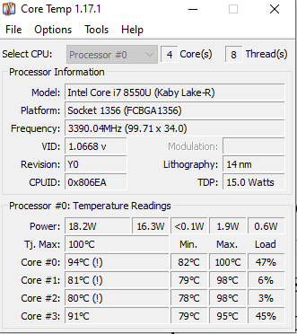

**The three fixes**

**Fix 1**

This fix can be applied to Windows operating systems of any version. Applying this fix can solve your overheating problem permanently. The only drawback is that it reduces a tiny bit of performance of your system but it isn’t so noticeable.

**Step 1:** Go to your windows taskbar. There you will see the battery icon. Right click on it and choose power options.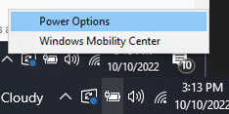

**Step 2:** In the new window pop up choose “Change plan settings” from the Balanced (recommended).

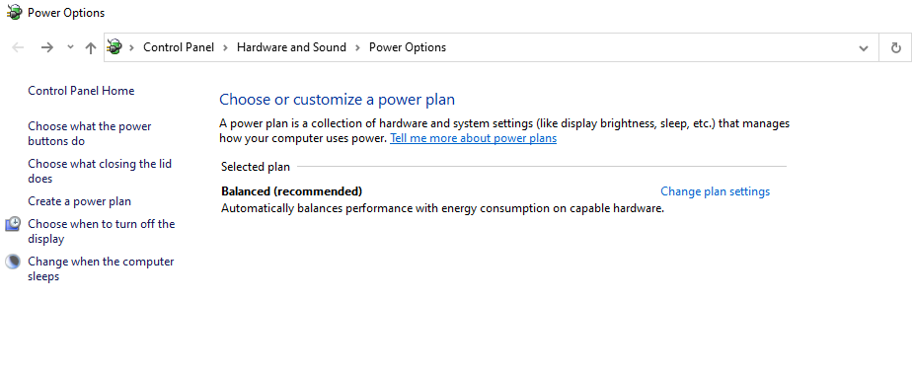

**Step 3:** In the new window that opens. You don’t need to configure anything. Just go to “ Change advanced power settings”. From there the magic happens.

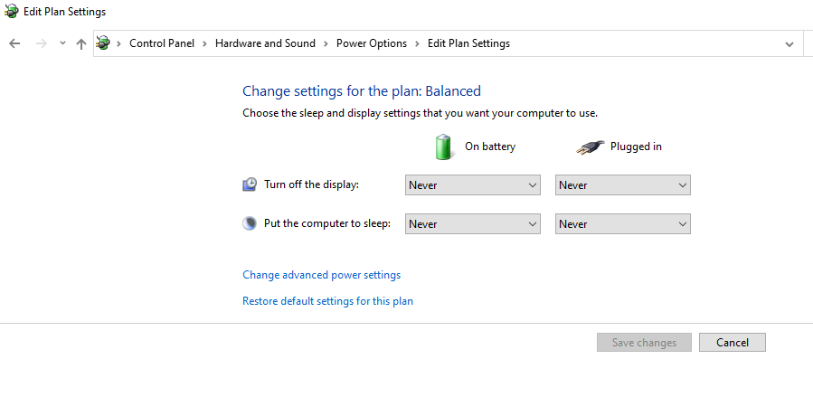

**Step 4:** Here, scroll down until you find processor power management. After you find it click it. Then you are required to choose from the three options. Choose the third one “Maximum processor state”. There you will find on battery and **plugged in**. It will be default set into 100% but you need to configure them and set both **on battery** and plugged in to **75%**. Don’t hit apply and ok now. It should be done in another step.

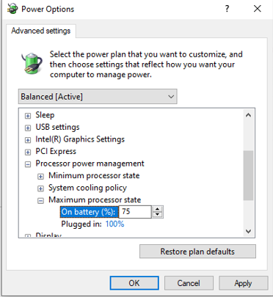

Step 5: In the same section. Choose system cooling policy. There you will find **on battery** and **plugged in**. Set them both to active. After setting up, hit apply and ok to see the final changes.

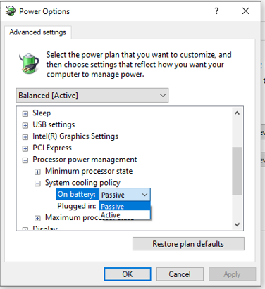

**Fix 2 – The cooling system**

The cooling system consists of fans and heat sinks. Clean them to fix the overheating issue. Follow the step by step guide to clean them:

* First of all, turn off your computer completely and detach all USB cables connected.
* Gather all the necessary equipment to open up the PC’s case. The equipment doesn’t necessarily need to be something excessive, just gather a paint brush or a toothbrush.
* Detach the heat sink and fans from the PC. Rotate the fan with your hand. If the fan isn’t spinning freely then and needs extra effort then it is clear that the fan is damaged and needs to be replaced.
* If either the fans or heat sink isn’t damaged then clean them properly to get dust out of them. If there is dust present in other components of the PC then clean them too.
* After doing so, attach the working fan and heat sink into the PC.
* Close the PC’s case and the problem of heating might be solved.

**Fix 3 – The cooling pads**

One of the best ways to deal with overheating issues in laptops is to buy a cooling pad. By placing a cooling pad under a laptop it helps to drop the temperature of the laptop. If you’re a gamer or someone who uses a laptop for a long duration of time then heating issues surely arise so it is required for you to buy a cooling pad. If you need a portable cooling pad to carry while traveling then buy something made of aluminum instead of plastic or steel as they are lightweight. The cooling pads don't boost your PC performance but solve the loud fan issues.

Some cooling pads don't get the job done so while buying a cooling pad, always take an expert opinion or look for a best seller in online websites.